SIMATS ENGINEERING
ASSESSMENT TOOL 1

COURSE NAME: CSA16 COURSE CODE: Data Warehousing and Data Mining

COURSE OUTCOME COVERED

CO2: Apply suitable Data Pre processing techniques like Data cleaning,Data intergration,Data transformation and data Reduction ,for effective data preparation (BL3,BL4)
Assessment Tool Weightage: 50%

QUESTIONS: 5 Total Marks:50

Annexure B
Analytical Problem Solving

Criteria | Problem Understanding (2) | Method Selection (2) | Solution Process (2.5) | Accuracy of Calculation (2) | Interpretation of Results (1.5) | Total(10)
Weightage | 20% | 20% | 25% | 20% | 15% | 100%
Q1
Q2
Q3
Q4
Q5

Code of Conduct:

I _M.Balaji (192525059)__ (Name / Reg No) certify that this submission is my original work and that I have adhered to the guidelines specified for this assessment.
I understand that any violation of academic integrity rules will result in disciplinary action.

Signature of the student:
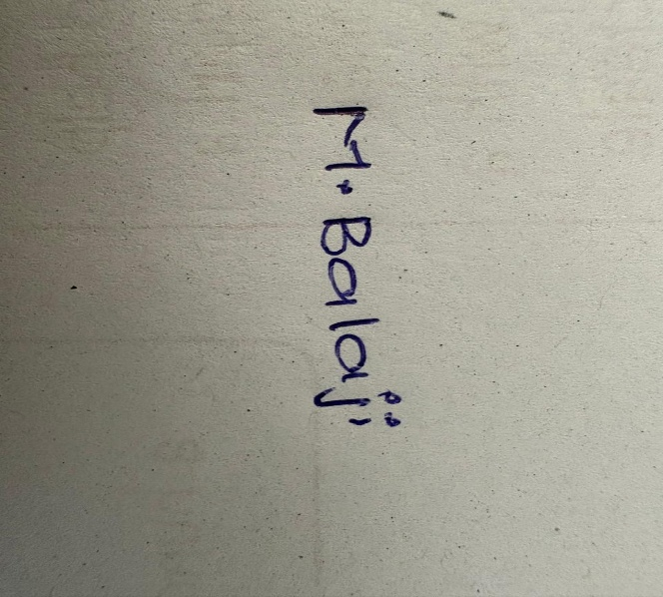

RUBRICS FOR CALCULATION:

Numerical Problems
Criteria | Weightage | Level 4 (Exemplary) | Level 3 (Proficient) | Level 2 (Developing) | Level 1 (Beginning)
Problem Understanding | 20% | Clearly interprets problem, identifies all parameters and requirements accurately | Understands problem with minor gaps | Partial understanding; misses key elements | Misinterprets or unable to understand problem
Method Selection | 20% | Selects most appropriate method/formula with strong justification | Selects correct method with minor errors | Inappropriate or partially correct method | Unable to select method
Solution Process | 25% | Logical, systematic steps with correct approach throughout | Mostly correct steps with minor mistakes | Disorganized steps; multiple errors | No clear process
Accuracy of Calculation | 20% | All calculations accurate; correct final answer | Minor calculation errors | Frequent errors; incorrect final answer | No valid calculations
Interpretation of Results | 15% | Clearly interprets results with units and engineering relevance | Basic interpretation with minor omissions | Limited or unclear interpretation | No interpretation

